LISTENING

PART 1 Questions 1-10

Questions 1-10
Complete the form below.
Write NO MORE THAN TWO WORDS AND/OR A NUMBER for each answer.

ORDER FORM
Example: | Answer
Reason for calf: | problems with WEBSITE
Name: | 1………………………………………….…..Freeman
Title of book: | 2………………
Author: | Richard 3…………………….
Type of book: | 4……………………
Price: | £5…………………..
Payment method: | 6 ………………………
Delivery address: | 7 ……………….., London N22
Delivery type: | 8 …………………….
Delivery date: | 9 …………………….
Delivery instructions: | If out leave with a 10 …………..

PART 2 QUESTIONS 11-20

Questions 11-16
Choose the correct letter, A, B or C.
11. What will wake people up in the home of the future?
A. Body temperature.
B. The sound of an alarm clock
C. The movement of the bed

12. What will shoes be able to do by themselves?
A. Walk faster
B. Play music
C. Float on air

13. What kind of clothes will people be wearing?
A. Clothes that make us more intelligent.
B. Clothes that can interpret how we are feeling
C. Clothes that are powered by electricity

14. What can the house do?
A. Control the shower temperature.
B. Turn off the taps.
C. Wash your back

15. What will the Internet be able to do?
A. Understand when you are worried
B. Project what’s in your fridge
C. Help find something you've lost

16. will the fridge do when people are low on milk?
A. Deliver the milk
B. Send an email to the shop
C. Defrost some in the freezer

Questions 17-20 Label the map below. Write the correct letter, A-F, next to questions 17-20.
The living room of the future
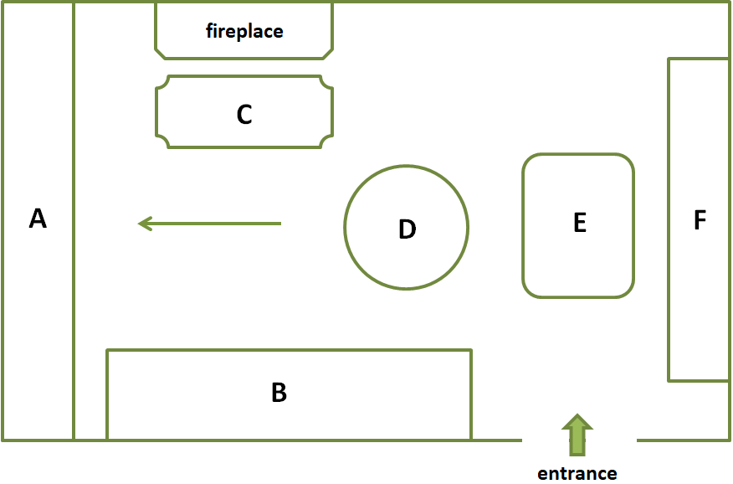
17. television
18. temperature control
19. bookcase
20. computer keyboard

PART 3 Questions 21-30

Questions 21-25
Choose FIVE letters, A-H. Which FIVE things has Sally already done?
A. emailed four businesses
B. written up results
C. contacted three businesses
D. started writing the assignment
E. read A Starting Success
F. skimmed a document
G. borrowed a book
H. researched data

Questions 26-30 Complete the flow-chart below. Choose FIVE answers from the box and choose the correct letter, A-G, for questions 26-30.

A beginning

B choices

C document

D document

E opening

F questions

G scales
How to write a questionnaire
26. Keep your ……………simple
27. Try to make the …………..of the document interesting.
28. Make sure that the …………….uses standard terms that aren’t too formal or informal
Limit or avoid open questions.
29. Use simple …………………..to make it quicker for the recipient.
30. Put your ………….in a logical order.

PART 4 QUESTIONS 31-40

Questions 31-40
Complete the notes below.
Write NO MORE THAN THREE WORDS AND/OR A NUMBER for each answer.

Impact of Urbanization
The effects of urbanization:
Example: in the U.S.
- Only 31……………. of land built on
- loss of 32 ………….far larger
- Could impact on world 33……………..in future
Research methods:
- a weather 34……………for clouds was used
- land use divided into 35 ………………..
- data used to calculate the 36…………of all areas
Results:
- urban areas often built on the 37……………….
- a second study confirmed that prime land is being converted
- 38………….of vegetation is lost per annum
The future:
- countries such as 39 …………..and need to do investigations
- stop investing in infrastructure in areas of fertile land
- encourage people to move by giving them 40 ………………

